Check if there´s one or more sites on the same property. For that you may:

- Check the names of the views (check if there´s multiple domains mentioned)
- Check Website´s URL on the Admin/View Settings
- On the Behavior/SiteContent/All Pages, apply hostname filter and see if there´s more than one domain tracked
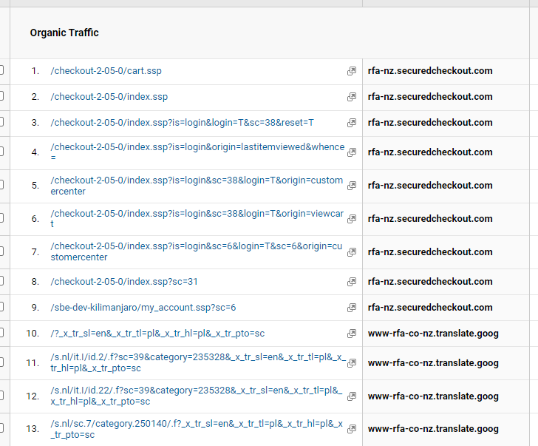
Aparece mas de un sitio acá, que hacemos?

Integrating the services: Tracking tools & Live chats
Setup/SuiteCommerce Advanced/Google Tag Manager Editor -> containers and

Agregar un servicio a un container de Google Tag Manager Editor -> agrego GA y falla

